

Network Security and Forensics

Lab Session 5

Submitted To:- Submitted By:-

Dr. Lokesh Chauhan Sir Saloni Rangari

M.Tech. AIDS

1. **Write a program to demonstrate the Vegenere Cipher  
   Input from file and Output into the file**

def vigenere_encrypt(plaintext,keyword):  
 encrypted_text = []  
 keyword_repeated = (keyword * (len(plaintext) // len(keyword) + 1))[:len(plaintext)]  
  
 for p,k in zip(plaintext,keyword_repeated):  
 if p.isalpha(): # Check if the character is an alphabet  
 shift = ord(k.lower()) - ord('a')  
 base = ord('A') if p.isupper() else ord('a')  
 encrypted_char = chr((ord(p) - base + shift) % 26 + base)  
 encrypted_text.append(encrypted_char)  
 else:  
 encrypted_text.append(p) # Non-alphabet characters are not changed  
  
 return ''.join(encrypted_text)  
  
  
def vigenere_decrypt(ciphertext,keyword):  
 decrypted_text = []  
 keyword_repeated = (keyword * (len(ciphertext) // len(keyword) + 1))[:len(ciphertext)]  
  
 for c,k in zip(ciphertext,keyword_repeated):  
 if c.isalpha(): # Check if the character is an alphabet  
 shift = ord(k.lower()) - ord('a')  
 base = ord('A') if c.isupper() else ord('a')  
 decrypted_char = chr((ord(c) - base - shift) % 26 + base)  
 decrypted_text.append(decrypted_char)  
 else:  
 decrypted_text.append(c) # Non-alphabet characters are not changed  
  
 return ''.join(decrypted_text)  
  
  
# Usage  
if __name__ == "__main__":  
  
 operation = int(input("Type 1 to encrypt or 2 to decrypt:"))  
  
 if operation == 1:  
  
 # Read plaintext and keyword from files  
 with open('e_plain_text.txt','r') as plaintext_file:  
 plaintext = plaintext_file.read()  
  
 with open('e_key.txt','r') as keyword_file:  
 key = keyword_file.read().strip()  
  
 print("Plain Text: ",plaintext) # Print the plaintext  
 print("Key: ",key) # Print the key  
  
 # Encrypt the plaintext  
 encrypted = (vigenere_encrypt(plaintext,key))  
  
 # Save the encrypted text to a file  
 with open('e_cipher_text.txt','w') as encrypted_file:  
 encrypted_file.write(encrypted)  
  
 # Decrypt the text back to verify  
 decrypted = vigenere_decrypt(encrypted,key)  
  
 print(f"Encrypted: {encrypted}")  
 print(f"Decrypted: {decrypted}")  
  
 elif operation == 2:  
  
 # Read plaintext and keyword from files  
 with open('d_cipher_text.txt','r') as ciphertext_file:  
 ciphertext = ciphertext_file.read()  
  
 with open('d_key.txt','r') as keyword_file:  
 key = keyword_file.read().strip()  
  
 print("Cipher Text: ",ciphertext) # Print the plaintext  
 print("Key: ",key) # Print the key  
  
 # Encrypt the plaintext  
 decrypted = vigenere_decrypt(ciphertext,key)  
  
 # Save the encrypted text to a file  
 with open('d_plain_text.txt','w') as decrypted_file:  
 decrypted_file.write(decrypted)  
  
 # Decrypt the text back to verify  
 encrypted = vigenere_encrypt(decrypted,key)  
  
 print(f"Encrypted: {encrypted}")  
 print(f"Decrypted: {decrypted}")

**Output:** Encryption

**Output:** Decryption

1. **Write a Program to demonstrate the AutoKey Cipher.  
   Input from file and Output into the file**

from importlib.metadata import pass_none  
  
  
def encrypt(plaintext: str, key: str) -> str:  
  
 if not isinstance(plaintext, str):  
 raise TypeError("plaintext must be a string")  
 if not isinstance(key, str):  
 raise TypeError("key must be a string")  
 if not plaintext:  
 raise ValueError("plaintext is empty")  
 if not key:  
 raise ValueError("key is empty")  
  
 key += plaintext  
 plaintext = plaintext.lower()  
 key = key.lower()  
 plaintext_iterator = 0  
 key_iterator = 0  
 ciphertext = ""  
 while plaintext_iterator < len(plaintext):  
 if (ord(plaintext[plaintext_iterator]) < 97  
 or ord(plaintext[plaintext_iterator]) > 122):  
 ciphertext += plaintext[plaintext_iterator]  
 plaintext_iterator += 1  
 elif ord(key[key_iterator]) < 97 or ord(key[key_iterator]) > 122:  
 key_iterator += 1  
 else:  
 ciphertext += chr(((ord(plaintext[plaintext_iterator]) - 97 + ord(key[key_iterator]))- 97) % 26 + 97)  
 key_iterator += 1  
 plaintext_iterator += 1  
 return ciphertext  
  
  
def decrypt(ciphertext: str, key: str) -> str:  
 if not isinstance(ciphertext, str):  
 raise TypeError("ciphertext must be a string")  
 if not isinstance(key, str):  
 raise TypeError("key must be a string")  
 if not ciphertext:  
 raise ValueError("ciphertext is empty")  
 if not key:  
 raise ValueError("key is empty")  
  
 key = key.lower()  
 ciphertext_iterator = 0  
 key_iterator = 0  
 plaintext = ""  
 while ciphertext_iterator < len(ciphertext):  
 if (  
 ord(ciphertext[ciphertext_iterator]) < 97  
 or ord(ciphertext[ciphertext_iterator]) > 122):  
 plaintext += ciphertext[ciphertext_iterator]  
 else:  
 plaintext += chr(  
 (ord(ciphertext[ciphertext_iterator]) - ord(key[key_iterator])) % 26 + 97)  
 key += chr(  
 (ord(ciphertext[ciphertext_iterator]) - ord(key[key_iterator])) % 26 + 97)  
 key_iterator += 1  
 ciphertext_iterator += 1  
 return plaintext  
  
# Usage  
if __name__ == "__main__":  
  
 operation = int(input("Type 1 to encrypt or 2 to decrypt:"))  
  
 if operation == 1:  
  
 # Read plaintext and keyword from files  
 with open('e_plain_text.txt','r') as plaintext_file:  
 plaintext = plaintext_file.read()  
  
 with open('e_key.txt','r') as keyword_file:  
 key = keyword_file.read().strip()  
  
 print("Plain Text: ",plaintext) # Print the plaintext  
 print("Key: ",key) # Print the key  
  
 # Encrypt the plaintext  
 encrypted = (encrypt(plaintext,key))  
  
 # Save the encrypted text to a file  
 with open('e_cipher_text.txt','w') as encrypted_file:  
 encrypted_file.write(encrypted)  
  
 # Decrypt the text back to verify  
 decrypted = decrypt(encrypted,key)  
  
 print(f"Encrypted: {encrypted}")  
 print(f"Decrypted: {decrypted}")  
  
 elif operation == 2:  
  
 # Read plaintext and keyword from files  
 with open('d_cipher_text.txt','r') as ciphertext_file:  
 ciphertext = ciphertext_file.read()  
  
 with open('d_key.txt','r') as keyword_file:  
 key = keyword_file.read().strip()  
  
 print("Cipher Text: ",ciphertext) # Print the ciphertext  
 print("Key: ",key) # Print the key  
  
 # Encrypt the plaintext  
 decrypted = decrypt(ciphertext,key)  
  
 # Save the encrypted text to a file  
 with open('d_plain_text.txt','w') as decrypted_file:  
 decrypted_file.write(decrypted)  
  
 # Decrypt the text back to verify  
 encrypted = encrypt(decrypted,key)  
  
 print(f"Decrypted: {decrypted}")  
 print(f"Encrypted: {encrypted}")

**Output:** Encryption

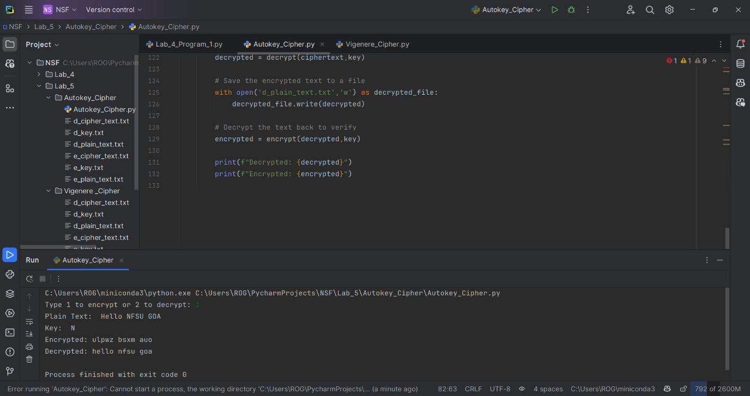

**Output:** Decryption

